MY UKRAINE!
Hello! I am Pavlina Medvedkova. I study at 10-th form, school of Mala Vilshanka.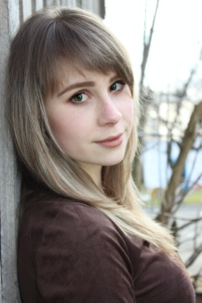
I live in our beautiful Ukraine.You know how many different villages and towns are in Ukraine. Large villages and small villages, small towns and big cities,stepps and forest,fields and mountains,rivers and seas…
This is our Ukraine,our Motherland,our native land,our only land. We have the only land for all of us,the only sky and the only sun. I live in one of this village-Selectsia. We have a big school,kinder garden,a lot of houses, good people, hospital and shops.
There are so many songs and poems about my native land. We can love only something that we know well. And we know a lot of about the history of our country. Ukraine has a long and glorious history.
We have some knowledge of our culture. That`s a beautiful songs,music,arts. And how beautiful the Ukraine language is! Love Ukraine with all your heart! We have always been a good neighbours,we have always loved our Ukraine,we shall always love it. Let us always be good friends and good neighbours in a village,in a town,in Ukraine, in Europe and in the whole world!
